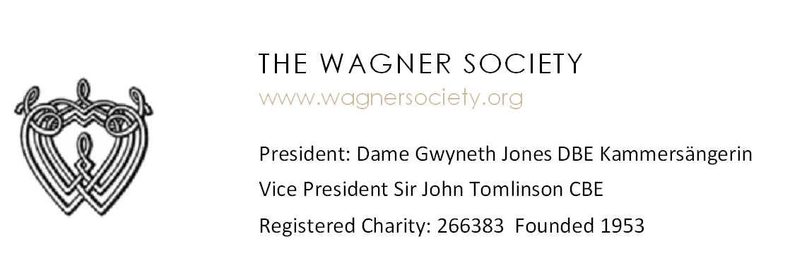
2019 BAYREUTH BALLOT SLIP
Name: ____________
Email: ____________________________________
PERFORMANCE | NUMBER OF TICKETS AVAILABLE | PRICE/ PRICE RANGE (£) | NUMBER OF TICKETS REQUESTED | ORDER OF CHOICE
Parsifal I 30th July 2019 | 2 | £280
Meistersinger II 31st July 2019 | 2 | £280
Tristan III 1st August 2019 | 2 | £280
Meistersinger IV 10th August 2019 | 8 | £280
Lohengrin V 11th August 2019 | 8 | £280
Lohengrin VI 14th August 2019 | 7 | £280
Parsifal IV 15th August 2019 | 12 | £280
Tristan III 16th August 2019 | 8 | £250
Tannhäuser IV 17th August 2019 | 5 | £340
Tannhäuser VI 25th August 2019 | 2 | £300
Parsifal VII 26th August 2019 | 12 | £150 or £310
Meistersinger VI 27th August 2019 | 6 | £190, £280 or £310
Tristan VI 28th August 2019 | 10 | £190, £220, £280 or £310

